

**Marine Script User Installation Guide**

**Nov 2009**Version 9.0.0

**Table of Contents**

1 Introduction 4

1.1 Purpose of the Document 4

1.2 Scope 4

1.3 Marine Script Functionality 4

2 Installation Steps 6

2.1 Pre-requisites 6

2.2 Welcome Dialog Box 6

2.3 Checking of Galileo Desktop 7

2.4 Silently install .Net Framework 2.0 (Setup with .Net Framework 2.0) 7

2.5 Copying the Files 8

2.6 Finish 9

# Introduction

## *Purpose of the Document*

This document is the solution proposal for the Marine Script Release. It specifically details the steps required to Install the Marine Script on your desktop.

## *Scope*

The scope for this document is limited to the Marine Script only.

## *Marine Script Functionality*

Marine script enables the agents to directly populate data from a standard excel template into a data mask and create a booking file based on it. The script reads information such as Passenger Surname, First name, Vessel name and Sea contact from the standardized excel template and adds it to the booking file.

The script also allows the agents to manually enter the information in the data mask which is then automatically added to the booking file.

User can execute the Marine script:

1) Via a Custom Toolbar button in the custom viewpoint toolbar.

The Marine script will perform the following tasks:

- The active booking file should be updated with the information from all the previous script masks.  
- Based on the selected option, the booking file finishing operation should be undertaken.

If an error message is returned by the host, it will be displayed to the user in a message box with an OK button (refer Figure 1 below). Click on the OK button to exit the script.

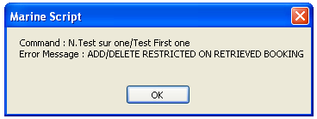

Figure

# Installation Steps

The Install Shield Developer 8 creates a setup file of the Marine Script.

Click on this executable file of the Marine Script.

## *Pre-requisites*

The following softwares should be installed on the computer before installing this setup.

* Galileo Desktop Version 1.0 and 2.x
* Windows® 2000 SP3, Windows® NT Service Pack 6a, Windows® Me and Windows® XP or Higher.
* .Net Framework 2.0 or above.
* MS Excel.

## *Welcome Dialog Box*

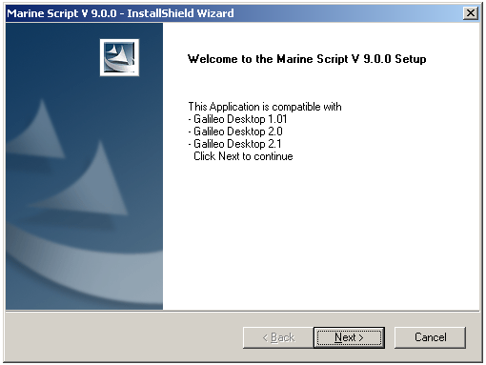

Figure

Click Next to continue.

## *Checking the Galileo Desktop*

As the user clicks on the Next button, some predefined validations occur such as:

Install Shield first check whether the Galileo Desktop Version 1.0 or 2.x has installed or not. If Galileo Desktop 1.0 or 2.x is not installed on the system, a prompt message will appear (refer Figure 3 below) and terminate the setup.

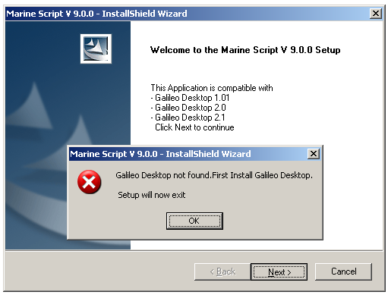

Figure

## *Silently install .Net Framework 2.0 (Setup with .Net Framework 2.0)*

Install shield also check whether the .net framework 2.0 or above is installed on the system or not. If the .net framework 2.0 or above is not installed on the system, the setup will silently install it including all other files related to this setup. (refer Figure 4 on the next page).

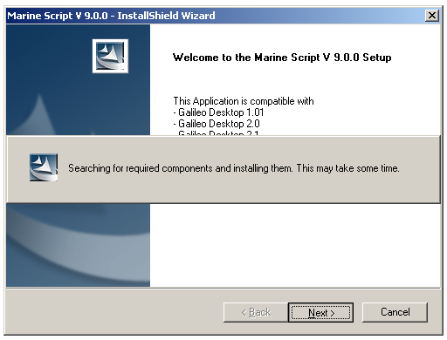

Figure

## *Copying the Files*

After all the conditions are validatd (Checking of Galileo Desktop 1.0 or 2.x and .Net Framework) the setup will copy all the files in the specified location<Drive Letter>\fp\swdir\Marine. (Figure 5).

As the user installs the Marine script, a button/icon will be added on the Custom Viewpoint Toolbar of the Galileo Desktop. By default the Marine script Installer searches the vptoolbar.xml file in <Drive Letter>\fp\swdir folder & subfolders and if this file is found, the installer does the following steps:

1. If entry for the Marine script is not available in VpToolbar.xml file then append a new entry for the Marine button and add the required Tag to the end of the vptoolbar.xml file.

In case the vptoolbar.xml file is not found, the installer will create the vptoolbar.xml file under <Drive Letter>/FP/SWDIR folder only.

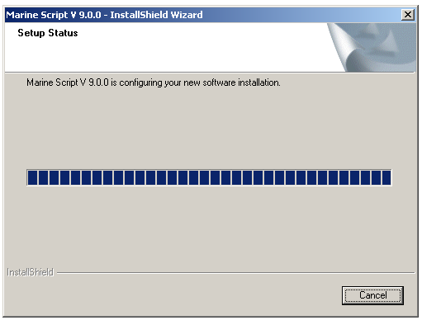

Figure

## *Finish*

This is the confirmation screen advising the user that the setup has finished successfully.

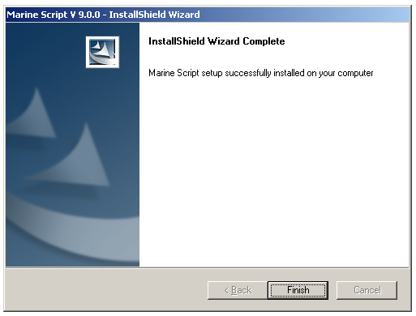

Figure

Copyright

©2009 Travelport Inc.  All rights reserved.  [insert list of trademarks used in document] are registered trademarks or trademarks of Travelport Inc. and/or its affiliates in the United States and/or other countries.  Other trademarks are property of their respective owners.

**Notes About Examples**

All screen examples and other inserts associated with system output are provided for illustration purposes only. They are provided as illustrative examples of system functionality and are not meant to represent actual screen responses, rates, etc.